Chapter 5

Questions and Problems and Answers

- Explain the advantages and disadvantages to a call buyer of closing out a position prior to expiration rather than holding all the way until expiration.
When a call is purchased, the buyer pays for both the time value and intrinsic value of the option. As the call gets closer and closer to expiration, it will lose its time value. At expiration of the call, the holder collects only the intrinsic value. By selling the call prior to expiration, the holder is able to recover some of the time value previously purchased. For a given stock price, this increases the profit or decreases the loss; however, the shorter the holding period, the less time the stock price has to move upward. The tradeoff in deciding whether to sell an option early is between cutting the loss of time value and giving the stock enough time to make a substantial move.
- Suppose one is considering buying a call at a particular exercise price. What reasons could be given for the alternative of buying a call at a higher exercise price? At a lower exercise price?
The call with a higher exercise price will be far more speculative, because the stock price must go higher in order to break even; however, the premium on such a call will be lower. A call with a lower exercise price will have a greater chance of expiring in the money; however, the premium will be higher. The tradeoff is between taking a gamble on the call with a higher exercise price at the cost of a small premium or buying the safer call with a lower exercise price at the cost of a larger premium.
- Explain how a protective put is like purchasing insurance on a stock.
A protective put establishes a minimum price at which a stock can be sold. In a bear market, the stock will lose value that can be recovered by exercising the put. This makes the put like an insurance policy that pays off in the event of a loss. The premium on the put is like the premium on the insurance policy. If the price of the stock goes up, the insurance is not needed, so the put is allowed to expire.
- Why is the choice of exercise price on a protective put like the decision on which deductible to take on an insurance policy?
The higher the exercise price, the higher the price at which the stock can be sold. This reduces the overall loss in a bear market, but, of course, will require a higher premium. It is, therefore, like taking a lower deductible in an insurance policy. By forcing the insurer (the put writer) to assume more of the potential loss, the cost of the insurance (the put premium) rises.
- Discuss and compare the two bullish strategies of buying a call and writing a put. Why would one strategy be preferable to the other?
Both strategies are indeed bullish. Buying a call gives you the option to buy the stock at a favorable price. Writing a put on the other hand, gives you the obligation to buy the stock at what might be an unfavorable price. Both the call buyers and put writer will profit in a bull market, but the call buyer will do better in a strong bull market because the profit will be higher the higher the stock price. The put writer’s profit is limited to the original premium received. In a bear market, the call buyer will have limited losses while the put writer will lose more the lower the stock price. All of this makes it sound as though the call buyer does better than the put writer, but this is not necessarily so. The call buyer is paying a premium while the put writer is receiving a premium. The put writer earns interest on the premium while the call buyer forgoes interest.
- Suppose you wish to buy stock and protect yourself against a downside movement in its price. You consider both a covered call and a protective put. What factors will affect your decision?
The covered call cuts losses on the downside and gains on the upside. In a bull market, the call is likely to be exercised and the stock called away. This limits the gain in a bull market to the amount of the premium plus the difference between the exercise price and the original stock price. A protective put cuts losses in a bear market but does allow gains in a bull market, which are higher the higher the stock price. Since a protective put is a synthetic call, the comparison is more appropriately seen as that of writing a covered call versus buying a call. Should we own stock and protect it with a short call or own simply the call? Both strategies are bullish, but the call (or protective put) would appeal more in situations where the investor is more concerned about taking advantage of a bull market than providing protection in a bear market.
- You have inherited some stock from a rich relative. The stock has had poor performance recently, and analysts believe it has little growth potential. You would like to write calls against the stock; however, the will stipulates that you must agree not to sell it unless you need the funds for a personal financial emergency. How can you write covered calls and minimize the likelihood of exercise?
You could concentrate on writing out-of-the-money calls; however, this would not guarantee that the stock would not be called away. The position must be carefully monitored. If the call moves in-the-money, it could be repurchased. Then you should write another out-of-the-money call. If the stock price continues to move upward, you continue to roll out of one exercise price into a higher exercise price. Disadvantages of this strategy are the potential for generating higher transaction costs and the trouble of monitoring the portfolio, as well as the fact that writing out-of-the-money calls produces relatively small premiums.
- We briefly mentioned the synthetic call, which consists of stock and an equal number of puts. Assume the combined value of the puts and stock exceeds the value of the actual call by less than the present value of the exercise price. Show how an arbitrage profit can be made. Note; do not use the data from the chapter. Show your point as it was illustrated in the text for the synthetic put.
If 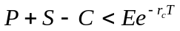, then the synthetic call (put+stock) is underpriced or the actual call is overpriced. So buy the synthetic call and sell the actual call. The payoffs from this portfolio at the expiration are
 | S_{T} < = E | S_{T} > E
Short call | 0 | -(S_{T} – E)
Long stock | S_{T} | S_{T}
Long put | (E - S_{T} ) | 0
Total | E | E

The cost of this portfolio is P+S-C, which we said was less than the present value of the exercise price. So we are essentially buying a portfolio that pays off E dollars for certain and paying a price that is less than the present value of E.
- A short position in stock can be protected by holding a call option determine the profit equations for this position, and identify the breakeven stock price at expiration and maximum and minimum profits.
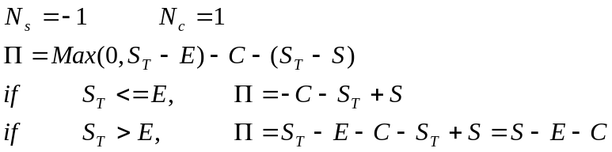
The breakeven is at a value of S_{T} <= E. Setting this profit equation to zero
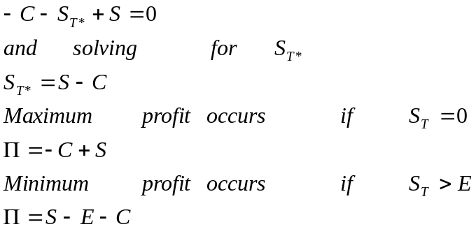
Which is negative since C must be greater than S-E
- A short stock can be protected by selling a put. Determine the profit equations for this position, and identify the breakeven stock price at expiration and maximum and minimum profits.
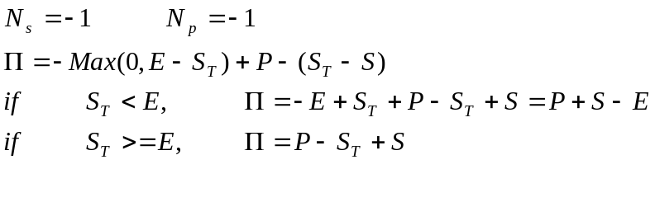
The breakeven is at a value of S_{T} > E. Setting this profit equation to zero
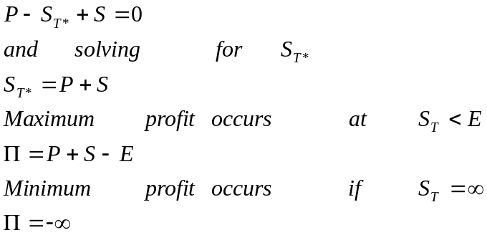

- Explain the advantages and disadvantages to a covered call writer of closing out the position prior to expiration.
Time value is directly related to time to expiration. If the covered writer closes out the position prior to the expiration, the call will be more expensive to repurchase. This reduces the profit for a given stock price. However, the shorter the holding period, the less time the stock price has to move downward. Writers of options benefit from short holding periods by giving the stock less time to move, but they have to buy back more of the original time value they received.
- Explain the considerations facing a covered call writer regarding the choice of exercise prices.
The lower the exercise price, the more protection the option is providing. This is because the call with the lower exercise price commands a higher premium and the premium cushions the loss on the downside. The disadvantage of a lower exercise price is that the option is more likely to be exercised and the upside gain is lower.

The following option prices were observed for a stock for July 6 of a particular year. Use this information in problems 13 through 18. Ignore dividends on the stock. The stock is priced at 165 1/8. The expirations are July 17, Aug 21, and Oct 16. The continuously compounded risk-free rates are 0.0503, 0.0535, and 0.0571 respectively. The standard deviation is 0.21. Assume the options are European.

Strike | Calls |  |  | Puts
Strike | July | Aug | Oct | Jul | Aug | Oct
165 | 2 11/16 | 5 ¼ | 8 1/8 | 2 3/8 | 4 ¾ | 6 ¾
170 | 13/16 | 3 ¼ | 6 | 5 ¾ | 7 ½ | 9

In problems 13 through 18, determine the profits for possible stock prices of 150, 155, 160, 165, 170, 175, and 180. Answer any other question as requested. Note; your excel spread sheet stratlyz1.xls will be useful here for obtaining graphs as requested, but it does not allow you to calculate the profits for several user-specified asset prices. It permits you to specify one asset price and a maximum and minimum. Use stratlyz1.xls to produce the graph for the range of prices from 150 to 180 but determine the profits for the prices of 150, 160, ……, 180 by hand for positions held to expirations. For positions closed prior to expirations, use the spreadsheet bsbin1.xls or the windows program bsbwin2.exe to determine the option price when the position is closed; then calculate the profit by hand.

- Buy one August 165 call contract. Hold until the option expires. Determine the profits and graph the results. Then identify the breakeven stock price at expiration. What is the maximum possible loss on this transaction?

C = 5.25

S_{T} | Call Price at | Profit
 | expiration
150 | 0 | -525
155 | 0 | -525
160 | 0 | -525
165 | 0 | -525
170 | 5 | -25
175 | 10 | 475
180 | 15 | 975

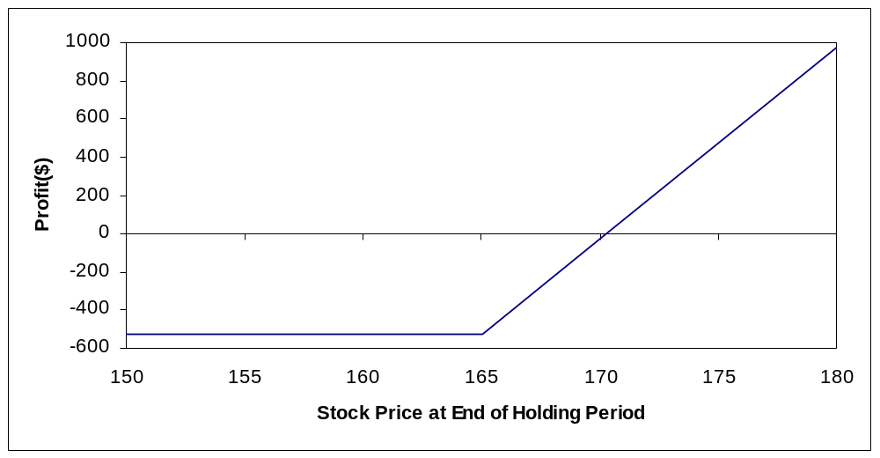

Breakeven: E + C = 165+5.25=170.25
Maximum Loss: 525 (the premium)

- Repeat problem 13, but close the position on August 1. Calculate the profit by hand when the stock price on August 1 is 155. Then use the spreadsheet or calculate by hand to find the profits for the possible stock prices on August 1. Generate a graph and use it to identify the approximate breakeven stock price.
E = 165 r_{c} = 0.0535 σ=0.21 C=5.25
T₁ = 20/365 = 0.0548 (based on 20 days between 8/1 and 8/21)
By hand with S_{T} = 155,
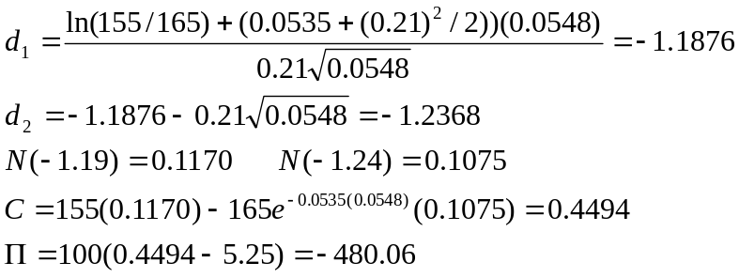
The results using a spread sheet are

S_{T} | Call Price at end | Profit
 | of Holding Period
150 | 0.0901 | -515.99
155 | 0.4295 | -482.05
160 | 1.4203 | -382.97
165 | 3.4782 | -177.18
170 | 6.7247 | 147.47
175 | 10.8992 | 564.92
180 | 15.5951 | 1034.51

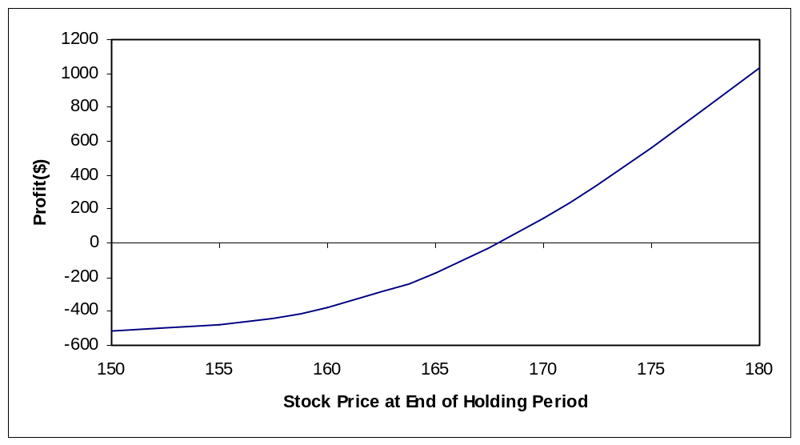

Breakeven stock price: approximately 168
Maximum loss: 525 (the premium)

- Buy one October 165 put contract. Hold until the options expire. Determine the profits and graph the results. Then identify the breakeven stock price at expiration. What are the maximum possible gain and loss on this transaction?

P= 6.75

S_{T} | Put Price at | Profit
 | Expiration
150 | 15 | 825
155 | 10 | 325
160 | 5 | -175
165 | 0 | -675
170 | 0 | -675
175 | 0 | -675
180 | 0 | -675

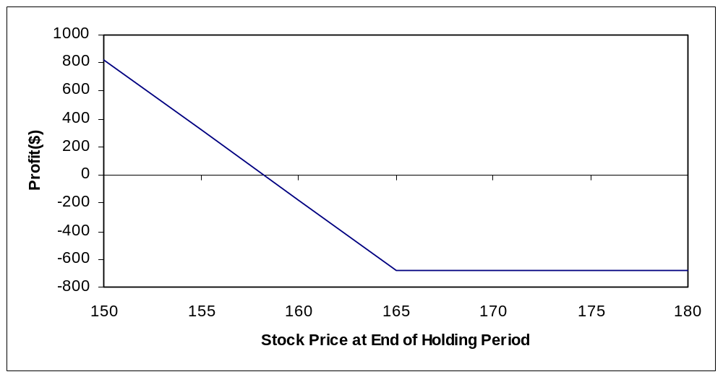

Breakeven: E-P = 165 – 6.75 =158.25
Maximum Loss: 675
Maximum gain (if S_{T} = 0) : 15,825

- Buy 100 shares of stock and write one October 170 call contract. Hold the position until expiration. Determine the profits and graph the results. Identify the breakeven stock price at expiration, the maximum profit, and the maximum loss?
C = 6

S_{T} | Call Price at | Profit | Profit | Overall
 | Expiration | from Call | from Stock | Profit
150 | 0 | 600 | (1,512.15) | (912.15)
155 | 0 | 600 | (1,012.50) | (412.50)
160 | 0 | 600 | (512.50) | 87.50
165 | 0 | 600 | (12.50) | 587.50
170 | 0 | 600 | 487.50 | 1,087.50
175 | 5 | 100 | 987.50 | 1,087.50
180 | 10 | -400 | 1,487.50 | 1,087.50

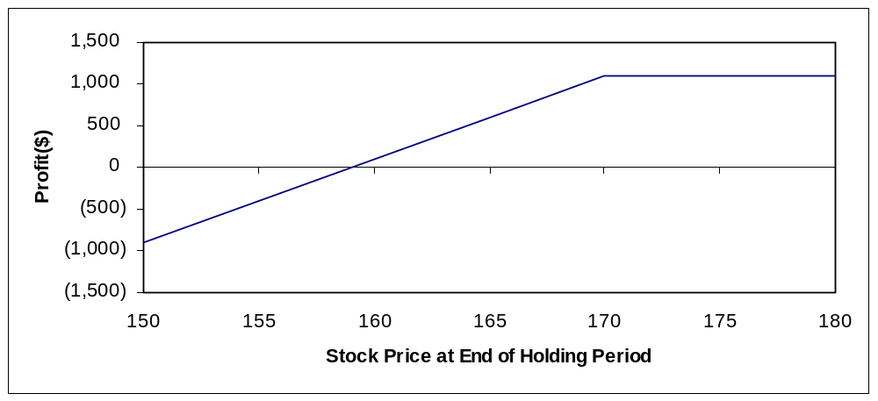

Breakeven: S-C = 165.125 – 6 =159.125
Maximum profit: 1,087.50
Maximum loss (if S_{T} = 0) :
Profit from Call = 600
Profit from Stock = -16,512.50
Overall Profit = -15,912.50

- Repeat problem 16, but close the position on September 1. Calculate the profit by hand when the stock price on September 1 is 155. Then use the spreadsheet or calculate by hand to find the profits for the possible stock prices on September 1. Generate a graph and use it to approximate the breakeven stock price.
E = 170 r_{c} = 0.0571 σ=0.21 C=6
T₁ = 45/365 = 0.1233 (based on 45 days from 9/1 to 10/16)
By hand with S_{T} = 155,
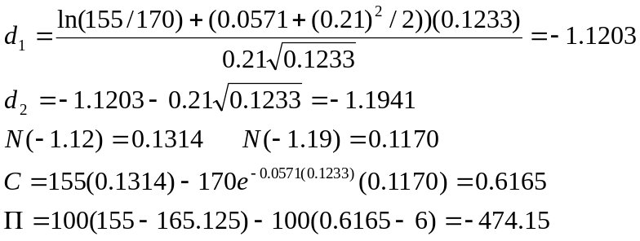
The results using a spread sheet are
S_{T} | Call Price at | Profit | Profit | Overall
 | end of Holding Period | from Call | from Stock | Profit
150 | 0.2714 | 572.86 | (1,512.50) | (939.64)
155 | 0.7297 | 527.03 | (1,012.50) | (485.47)
160 | 1.654 | 434.6 | (512.50) | (77.90)
165 | 3.2381 | 276.19 | (12.50) | 263.69
170 | 5.6014 | 39.86 | 487.50 | 527.36
175 | 8.7436 | -274.36 | 987.50 | 713.14
180 | 12.554 | -655.4 | 1,487.50 | 832.10

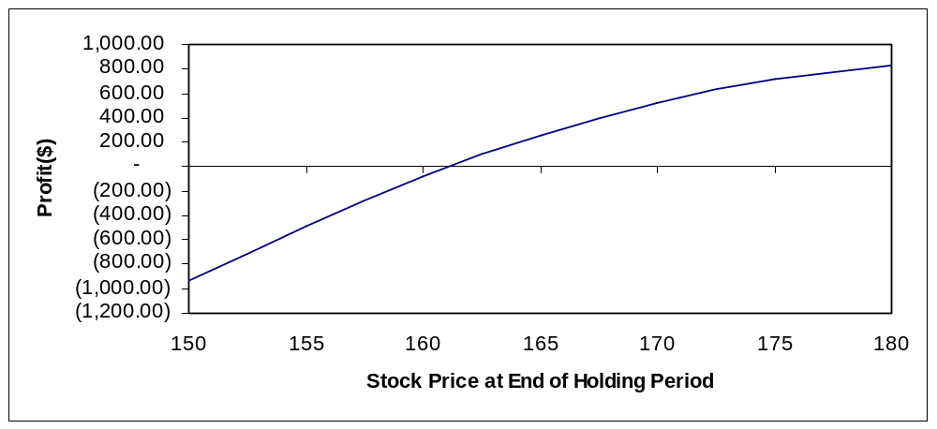

Breakeven stock price 162

- Buy 100 shares of stock and buy one August 165 put contract. Hold the position until expiration. Determine the profits and graph the results. Determine the breakeven stock price at expiration, the maximum profit, and the maximum loss.

P = 4.75

S_{T} | Put Price at | Profit | Profit | Overall
 | Expiration | from Put | from Stock | Profit
150 | 15 | 1025 | (1,512.50) | (487.50)
155 | 10 | 525 | (1,012.50) | (487.50)
160 | 5 | 25 | (512.50) | (487.50)
165 | 0 | -475 | (12.50) | (487.50)
170 | 0 | -475 | 487.50 | 12.50
175 | 0 | -475 | 987.50 | 512.50
180 | 0 | -475 | 1,487.50 | 1,012.50

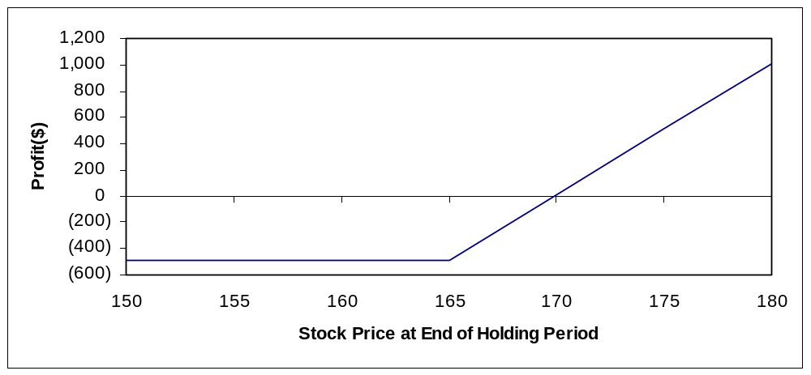

Breakeven: P+S = 4.75 + 165.125 = 169.875
Maximum Profit:
Maximum Loss : 487.50

- (Concept Problem) In each case examined in the chapter and in the preceding problems, we did not account for the interest on funds invested. One useful way to observe the effect of interest is to look at a conversion or a reverse conversion. Evaluate the August 165 puts and calls, and recommend a conversion or a reverse conversion. Determine the profit from the transaction if the options are held to expiration. Make sure the profit properly accounts for the interest that accrues over the holding period.

This is a reverse conversion.

Sell Put +4.75
Buy Synthetic Put
Buy Call -5.25
Sell stock +165.125
Net cash in 164.625

Invest at 5.35% to grow to 164.625 (1.0535)^{0.1260} = 165.71

Amount owed at expiration = 165

Net gain = 0.71

- (Concept Problem) Another consideration in evaluating option strategies is the effect of transaction costs. Suppose purchases and sales of an option incur a brokerage commission of 1 percent of the option’s value. Purchases and sales of a share of stock incur a brokerage commission of 0.5 percent of the stock’s value. If the option is exercised, there is a transaction cost on the purchase or sale of the stock. Determine the profit equations for the following strategies assuming the options are held to expiration and exercised if in-the-money rather than sold back. Assume that one option and / or share is used and that any shares left in the portfolio are sold.
  - Long call
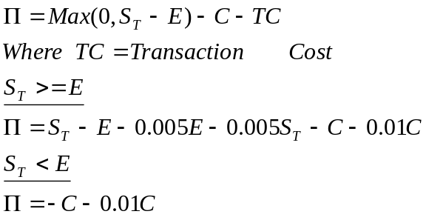
  - Long put
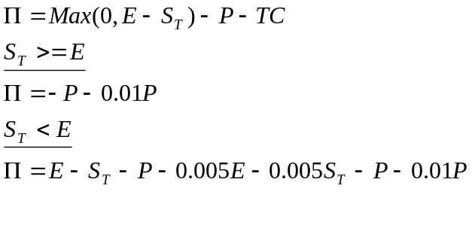
  - Covered call
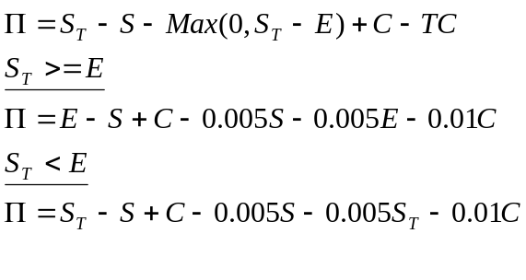

  - Protective put
